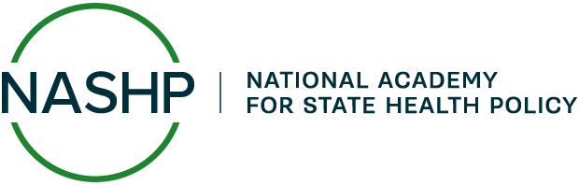
Caregivers Communications and Marketing Toolkit:
Sample Call-to-Action

Below are sample calls to action that can be adapted for flyers, social media, newsletters, and other communication materials:

- Do you help a loved one with daily tasks, errands, or medical needs? You’re a caregiver. And support is here for you. Call [###-###-####] or visit [link] today.
- Getting support isn’t giving up, it’s caring smarter. Take the first step: call [###-###-####] or visit [link].
- November is National Family Caregivers Month, and free or low-cost help is available. Visit [link] or call [###-###-####].
- You care for them. It’s time to care for you, too. Learn about services available to you. Visit [link] or call [###-###-####] to get started.
- Join us in honoring caregivers this month. Find local events, resources, and support by calling [###-###-####] or visiting [link].

